Transformation Matrices

非沿着XY轴缩放：

1. 旋转到沿着XY轴；
2. 缩放；
3. 旋转回来。

Decomposition of Transformations

Symmetric Eigenvalue Decomposition

A = RSRT

In geometric terms we can now recognize R as a rotation and S as a scale.

对称矩阵只是一种缩放操作--尽管可能是不均匀的和非轴对齐的缩放操作。

Singular Value Decomposition

A = USVT

1. Rotate v1 and v2 to the x- and y-axes (the transform by VT).

2. Scale in x and y by (σ1, σ2) (the transform by S).

3. Rotate the x- and y-axes to u1 and u2 (the transform by U).

Paeth Decomposition of Rotations

将非零的旋转矩阵分解为多个斜切矩阵

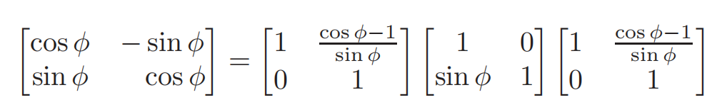

Arbitrary 3D Rotations

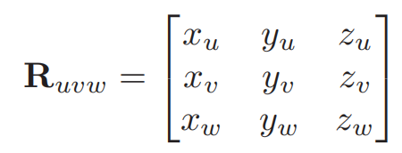

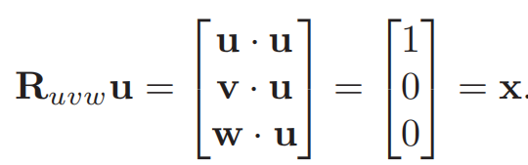

Similarly, Ruvwv = y, and Ruvww = z. So Ruvw takes the basis uvw to the corresponding Cartesian axes via rotation.

If we wish to rotate about an arbitrary vector a, we can form an orthonormal

basis with w = a, rotate that basis to the canonical basis xyz, rotate about the

z-axis, and then rotate the canonical basis back to the uvw basis. In matrix form,

to rotate about the w-axis by an angle φ:

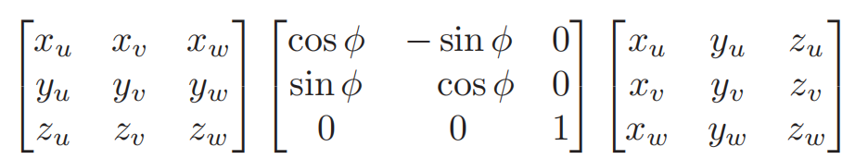

Coordinate Transformations

